**Data types**

Data type determines the type of data a variable will hold. If a variable x is declared as int. it means x can hold only integer values. Every variable which is used in the program must be declared as what data-type it is.

The data-type in a programming language is the collection of data with values having fixed meaning as well as characteristics. Some of them are an integer, floating point, character, etc. Usually, programming languages specify the range values for given data-type.

C Data Types are used to:

* Identify the type of a variable when it declared.
* Identify the type of the return value of a function.
* Identify the type of a parameter expected by a function.

ANSI C provides three types of data types:

1. **Primary(Built-in) Data Types**:  
   *void*, *int*, *char*, *double* and *float*.
2. **Derived Data Types**:  
   *Array*, *References*, and *Pointers*.
3. **User Defined Data Types**:  
   *Structure*, *Union*, and *Enumeration*.

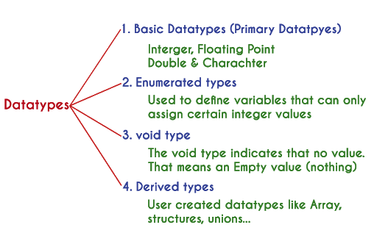

Every C compiler supports five primary data types:

|  |  |
| --- | --- |
| void | As the name suggests, it holds no value and is generally used for specifying the type of function or what it returns. If the function has a void type, it means that the function will not return any value. |
| int | Used to denote an integer type. |
| char | Used to denote a character type. |
| float, double | Used to denote a floating point type. |
| int *, float *, char * | Used to denote a pointer type. |

## Integer type

Integers are used to store whole numbers.

**Size and range of Integer type on 16-bit machine:**

|  |  |  |
| --- | --- | --- |
| **Type** | **Size(bytes)** | **Range** |
| int or signed int | 2 | -32,768 to 32767 |
| unsigned int | 2 | 0 to 65535 |
| short int or signed short int | 1 | -128 to 127 |
| unsigned short int | 1 | 0 to 255 |
| long int or signed long int | 4 | -2,147,483,648 to 2,147,483,647 |
| unsigned long int | 4 | 0 to 4,294,967,295 |

## Floating point type

Floating types are used to store real numbers.

**Size and range of Integer type on 16-bit machine**

|  |  |  |
| --- | --- | --- |
| **Type** | **Size(bytes)** | **Range** |
| Float | 4 | 3.4E-38 to 3.4E+38 |
| double | 8 | 1.7E-308 to 1.7E+308 |
| long double | 10 | 3.4E-4932 to 1.1E+4932 |

## Character type

Character types are used to store characters value.

**Size and range of Integer type on 16-bit machine**

|  |  |  |
| --- | --- | --- |
| **Type** | **Size(bytes)** | **Range** |
| char or signed char | 1 | -128 to 127 |
| unsigned char | 1 | 0 to 255 |

## void type

void type means no value. This is usually used to specify the type of functions which returns nothing. We will get acquainted to this datatype as we start learning more advanced topics in C language, like functions, pointers etc.

In C programming, data types are declarations for variables. This determines the type and size of data associated with variables. For example,

int myVar;

Here, myVar is a variable of int (integer) type. The size of int is 4 bytes.

## Basic types

Here's a table containing commonly used types in C programming for quick access.

|  |  |  |
| --- | --- | --- |
| **Type** | **Size (bytes)** | **Format Specifier** |
| int | at least 2, usually 4 | %d |
| char | 1 | %c |
| float | 4 | %f |
| double | 8 | %lf |
| short int | 2 usually | %hd |
| unsigned int | at least 2, usually 4 | %u |
| long int | at least 4, usually 8 | %li |
| long long int | at least 8 | %lli |
| unsigned long int | at least 4 | %lu |
| unsigned long long int | at least 8 | %llu |
| signed char | 1 | %c |
| unsigned char | 1 | %c |
| long double | at least 10, usually 12 or 16 | %Lf |